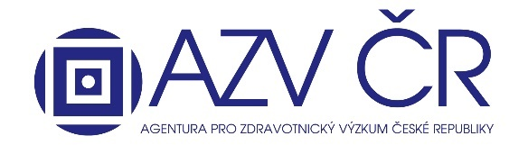

The Ministry of Health of Czech republic is opening a call for proposals for health research and development projects within the Program for the Support of Applied Medical Research for the Years 2024 – 2030 Program na podporu zdravotnického aplikovaného výzkumu na léta 2024 – 2030 (kód „NW“) – Ministerstvo zdravotnictví (mzcr.cz)
Detailed information here:
Vyhlášení jednostupňové veřejné soutěže o účelovou podporu MZ na léta 2024 – 2027 – AZV ČR (azvcr.cz)

Competition period: 17/05/2023 - 29/06/2023 (until 12:00 p.m.).

Beginning of projects: May 1, 2024

Project duration: 44 months.

Total allocated amount: CZK 200 million; of which 10% for projects of junior researchers.
Junior researchers: project costs up to CZK 7 million.

Maximum intensity of support for VO: up to 100%

Applicants can be both research organizations and businesses; It is possible to apply independently or in cooperation with a company, however a joint application with a company is favored in the evaluation process.

Subject of the competition: applied research projects, with a given application of the results in the healthcare sector: solving problems associated with the diagnosis, treatment and prevention of human diseases.

Program to support applied medical research for the years 2024 – 2030:
The main goal of the Program is to contribute to the provision and further development of international medical research in the Czech Republic

• Subprogramme 1: will support projects whose solution can only be a natural person engaged in research who, at the time of submitting the project proposal to the public competition, has an academic Ph.D. degree, its equivalent or higher.
• Sub-programme 2: will support projects of junior researchers no more than 8 years after the award of the Ph.D. or its equivalent, or obtains it no later than the date of conclusion of the contract/issuance of a decision on the solution of the project.

