Bachelor’s and Master’s Project
How mitochondria make room to breathe?
Advisors: doc. Hassan Hashimi Ph.D. & Corinna Benz, PhD.
Annotation: The saying “mitochondria are called the powerhouses of the cell” seems to be as common as the organelle itself, as it is found throughout all eukaryotes (including animals, plants and mushrooms). However, it is the small sub-compartments called cristae that make mitochondria the powerhouse as it is they that allow cells to breathe, which generates energy to keep the cell alive (Figure 1). Cristae are very complex structures that incorporate special membrane phospholipids and machinery called protein complexes. Our group is interested in how the assembly and/or transformation of these two elements are coordinated to make cristae. Furthermore, we are interested to see how changes in these programs give rise to the diverse crista shapes seen in different eukaryotes (Figure 2). We also want to know if these different shapes make cristae doe their cellular respiration task differently? We use protists models like trypanosomes and ciliates, which we can easily grow and genetically manipulate in the lab, because we are able to recapitulate how crista development occurs. We will apply typical molecular and cellular methods to get answers to these questions as well as sophisticated ‘omics’ and electron microscopy approaches.
If interested, please contact Hassan Hashimi (hassan@paru.cas.cz)

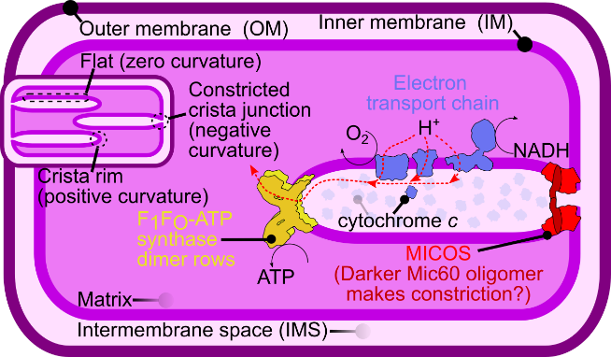
Figure 1: A simple schema of a mitochondria and a crista (left) and typical mitochondria from various lifeforms (right)

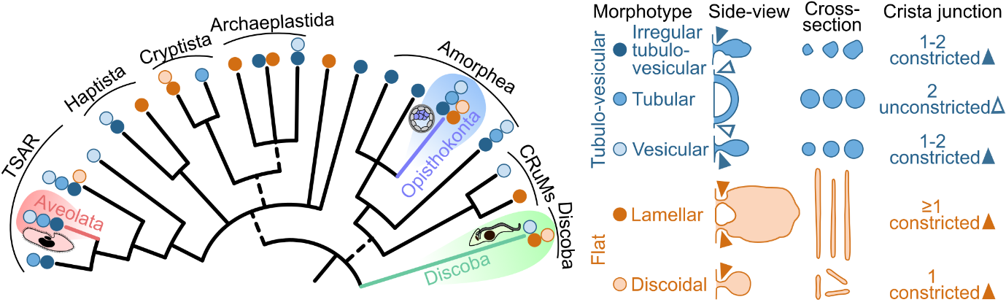
Figure 2: Crista shape diversity in eukaryotes.

